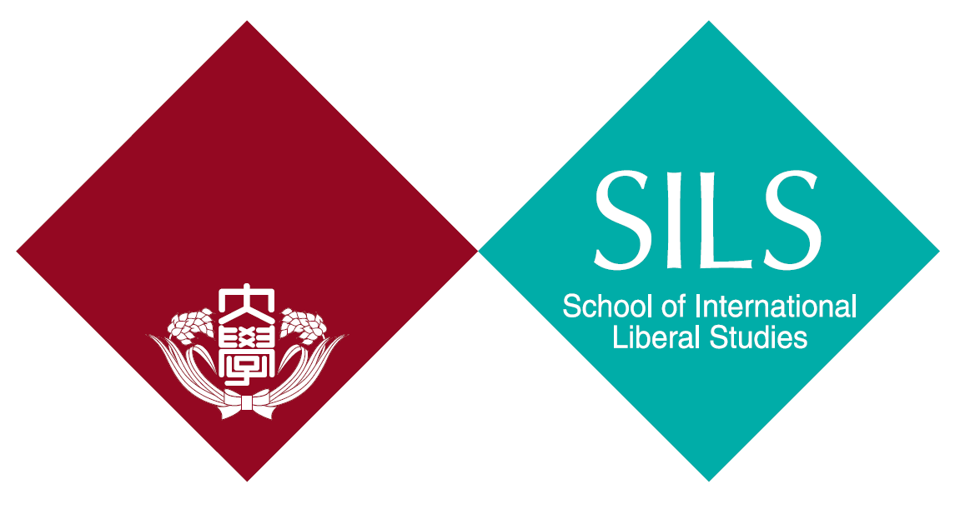

Waseda University
School of International Liberal Studies (SILS)
High School Recommendation Admissions

Letter of Recommendation

To the Dean of the School of International Liberal Studies, Waseda University,

We hereby recommend the applicant listed below for the "High School Recommendation Admissions (2022 September Enrollment)". For this recommendation, we have confirmed that the applicant fully understands the purpose and is eligible to apply for this admission.

Full name of the Applicant | Date of Birth
Year Month Day
/ /

 | Official Name of the School | School Official Seal
 | Telephone | School Official Seal
 | E-mail | School Official Seal
 | Principal’s Name | School Official Seal
 | Principal’s Signature | School Official Seal
 | Date | School Official Seal
*Please fill in all the boxes below

